DISA STIGs Compliance for Log360
Strengthen cybersecurity and meet DISA STIGs compliance with Log360.
Region: USA | Type: Industry Standard, Incident Management | Category: Compliance | Pricing: Free

Overview
The DISA STIGs compliance extension in Log360 helps organizations meet DISA STIGs, the mandatory US Department of Defense security configuration standards for IT systems on DoD networks mapped to NIST SP 800-53 Rev 5 via Control Correlation Identifiers by providing centralized log management, continuous monitoring, and threat detection. The platform supports DISA STIGs requirements for access control, audit and accountability, identification and authentication, configuration management, system and communications protection, system integrity, contingency planning, and incident response.
For Access Control (AC), Log360 monitors AD logon reports, Windows and Unix logon events, failed logon attempts, user auditing, terminal service sessions, and Entra ID user logon to continuously validate STIG access control compliance. To address Audit and Accountability (AU), the platform captures SQL Server and Oracle audit server records, Windows event and system logs, event log reports, detailed system events, computer auditing, and GPO auditing to build complete audit trails required by STIG AU controls. The extension also supports Identification and Authentication (IA) by providing capabilities that tracks MFA admin events, MFA authentication events, user account changes, Entra ID MFA logon activity, and AD password auditing reports to verify STIG IA control compliance.

Key Features
- Configuration Management (CM): Log360 detects unauthorized registry modifications, policy changes, software update events, process tracking, application whitelisting violations.
- System and Communications Protection (SC): Log360 monitors network device rule management, firewall security events, network logon and attack reports, policy management, Windows firewall auditing.
- System and Information Integrity (SI): Log360 monitors Windows threat detection, anti-malware events, Trend Micro security, FireEye reports, Unix threats, and software updates to validate STIG SI control compliance.
- Contingency Planning (CP): Log360 monitors Windows backup and restore events, backup and disaster recovery infrastructure, BDR jobs, BDR policies, and BDR malware detection to validate STIG CP control compliance.
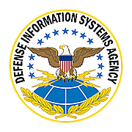
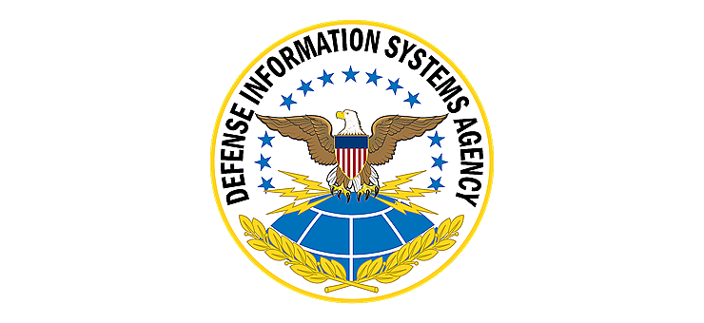
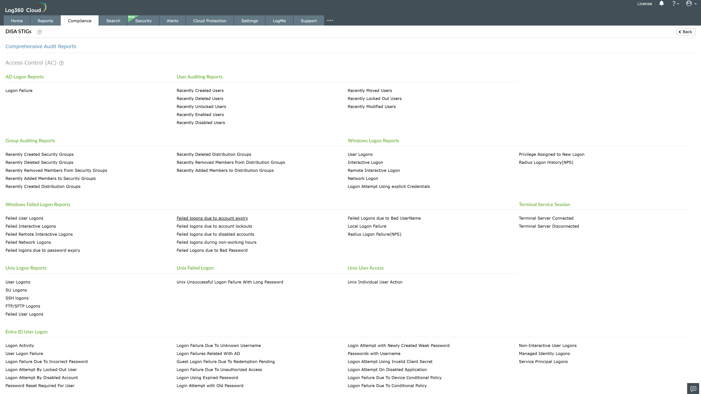
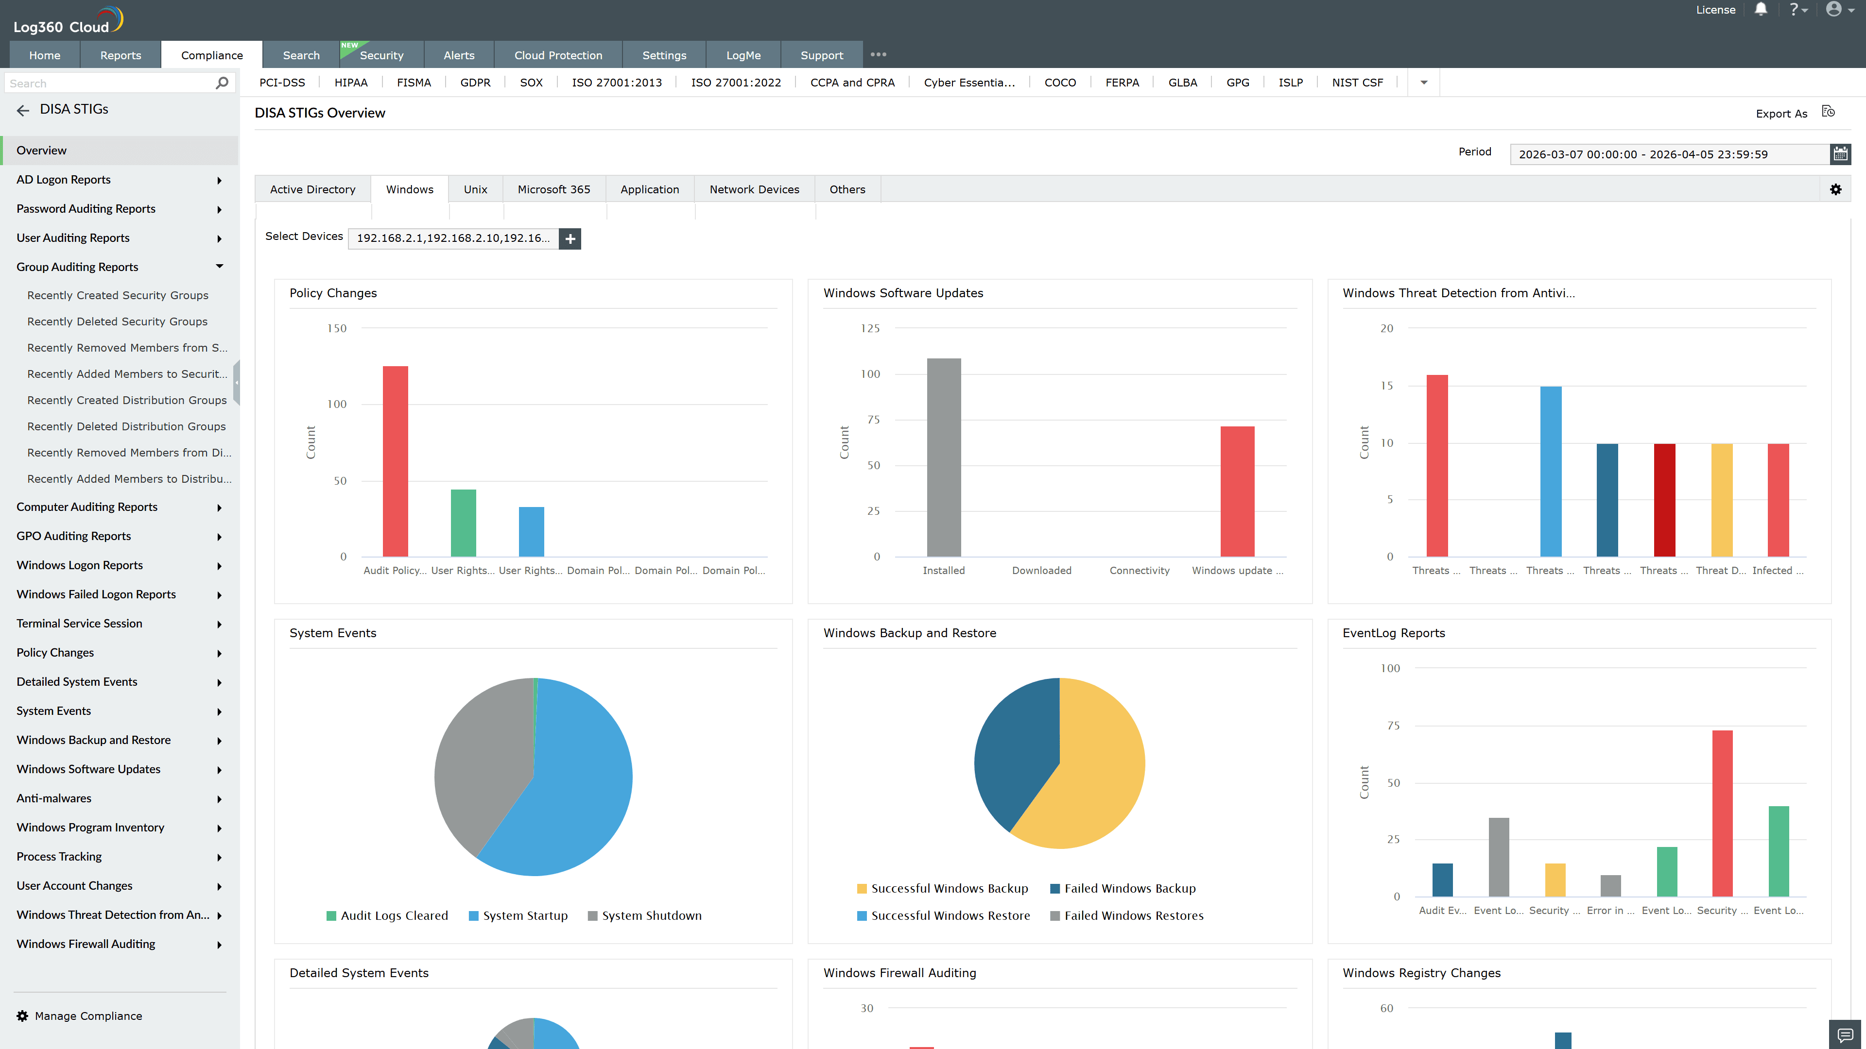
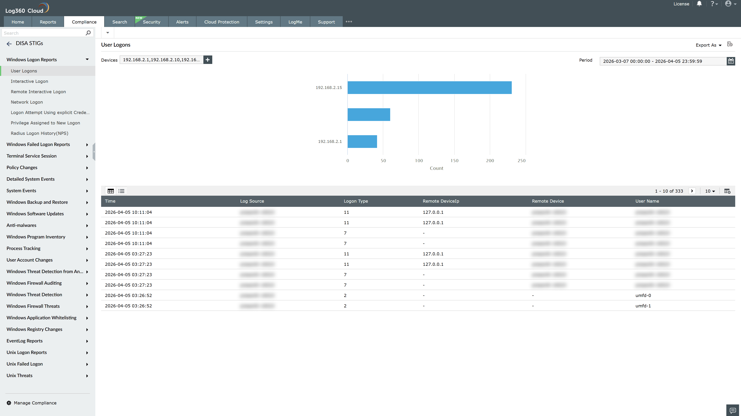
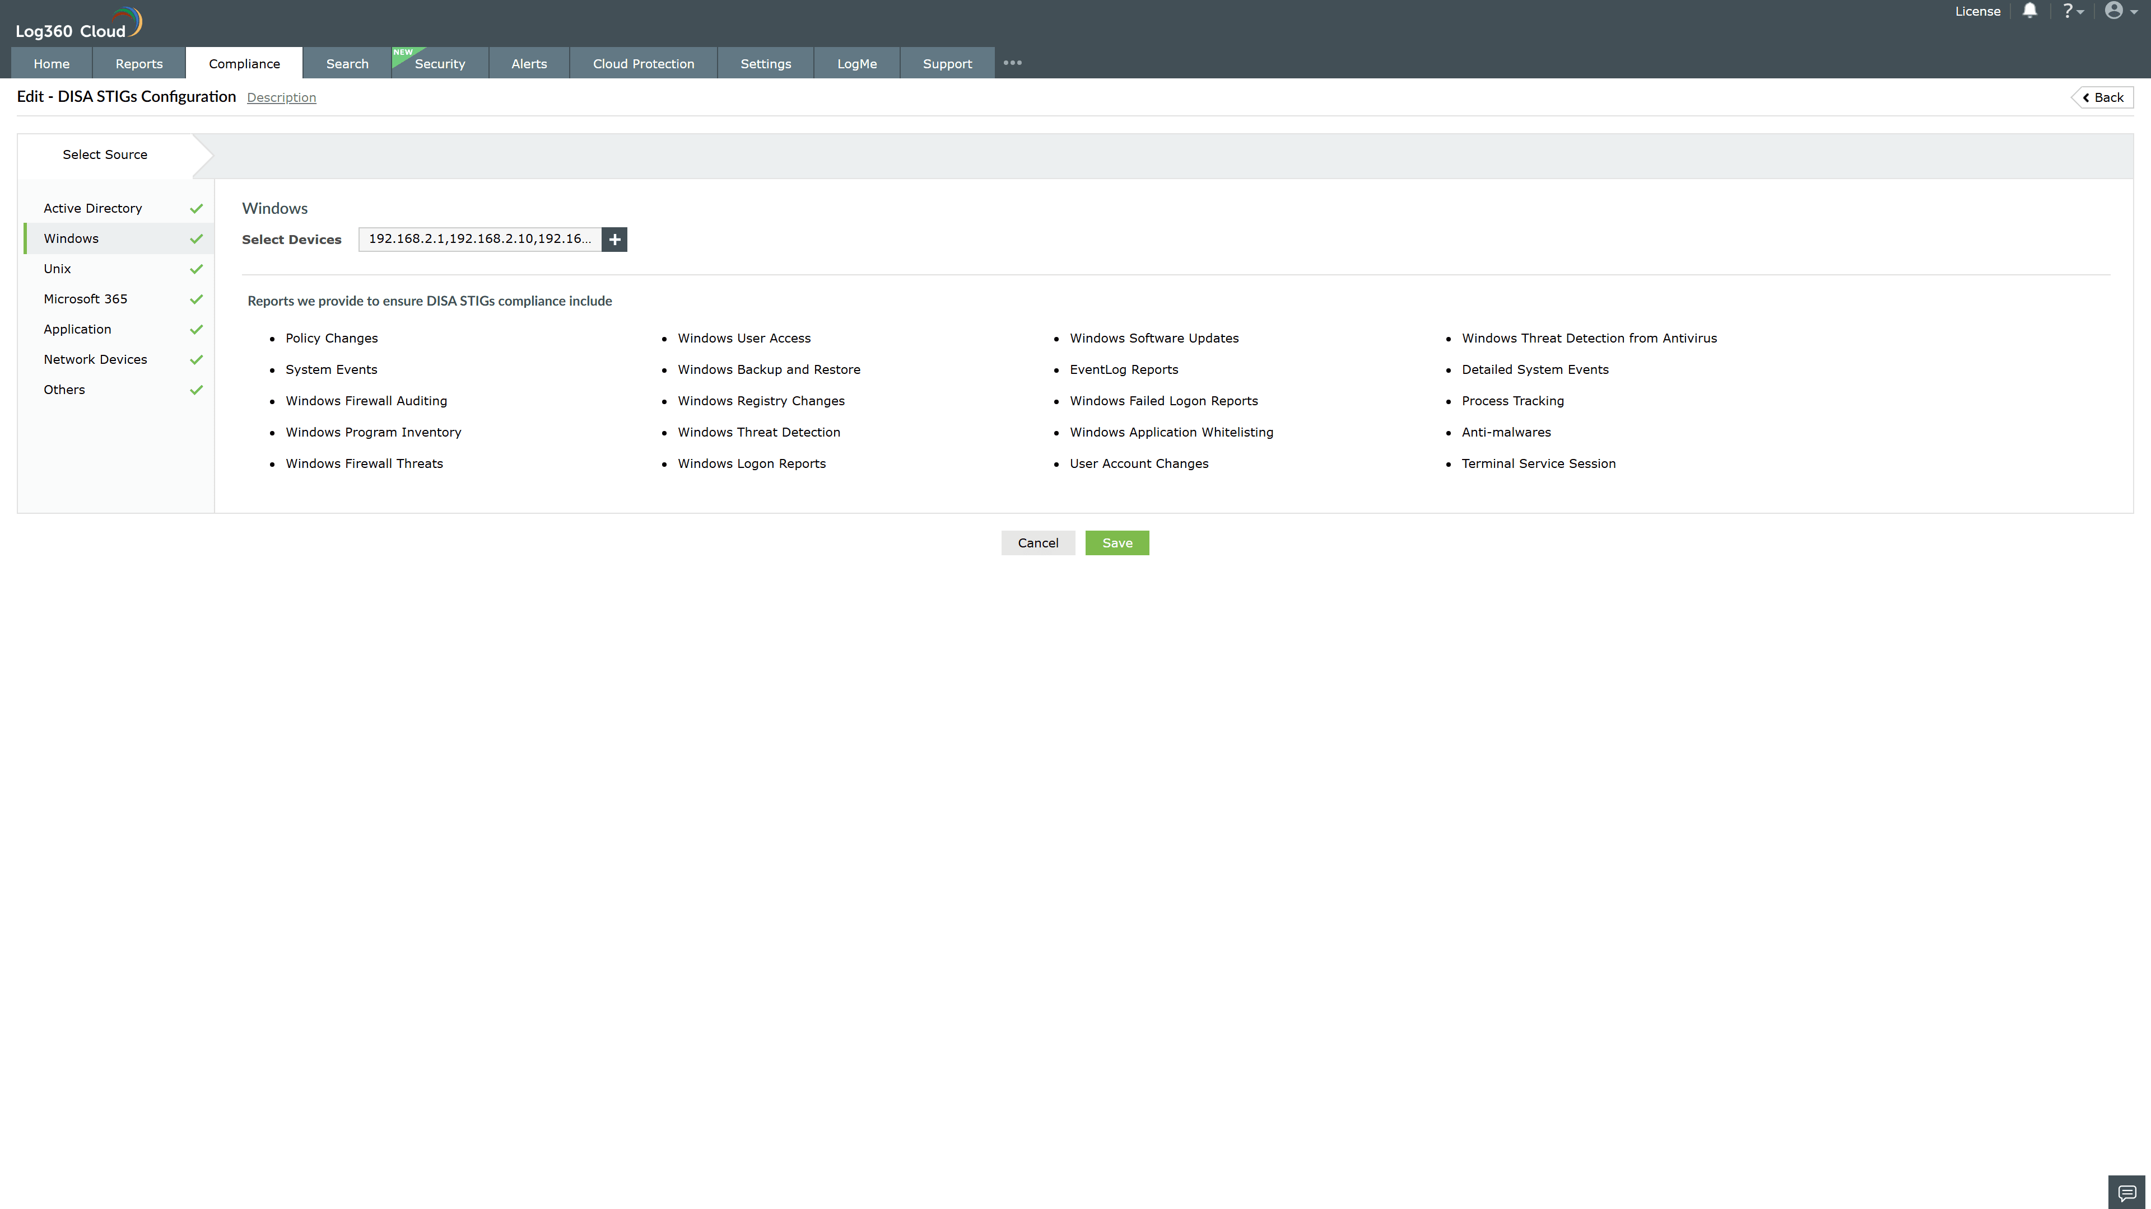
Valid Submission : Yes
Supported Editions : Free, Basic, Standard, Professional, MSSP
Help Document : https://www.manageengine.com/log-management/help/integrations/compliance-extensions.html
Help Video : Not provided
Tags : Log360, Compliance, Privacy monitoring, Data privacy, Regulatory compliance
Supported DCs : US, IN, JP, CA, AU, UK and EU
Privacy Policy:
Terms of Service:
Release Notes:
Predefined reports for the DISA STIGs.

